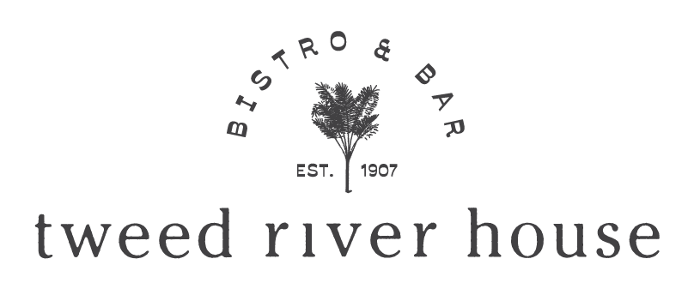

LARGE GROUP DINING EXPERIENCES

For bookings of 7 to 12 guests, please refer to our separate information sheet here

DINING AREAS You can view our dining areas here

Subject to size and availability you can choose to dine in either the River Verandah, Dining Room, Chandelier Private Dining Room, or book out the whole venue.

Depending on group size, we can do a large table or split across adjacent tables. Final layout depends on size and which dining area.

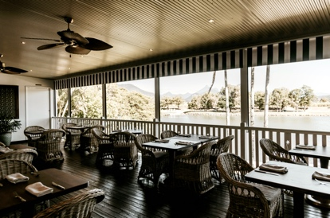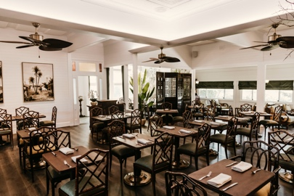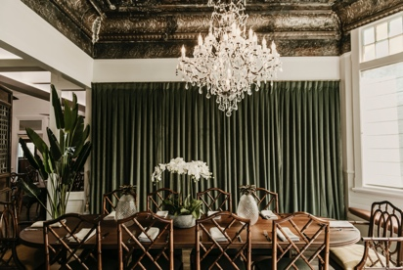
RIVER VERANDAH DINING ROOM CHANDELIER PRIVATE DINING

Seats
River Terrace 36
Dining Room 70
Chandelier Private Dining Room 12
All of venue 90

MINIMUM SPEND
A minimum spend applies for large group bookings. Food and beverage go towards the total. Any unused spend cannot be carried over or refunded. Any surcharges including service charge are on top of minimum spend.

You can also reserve a dining area or the whole restaurant for private and exclusive use.

Please complete the form on the last page and return to us so we can quote your group

TIME
For large group bookings, we allocate 3 hours.
Lunch service ends 5.00pm and dinner service at 10.00 pm
If you require longer this must be requested with prior agreement.

SURCHARGES
- 10% applies to bookings on Sundays and 15% on Public Holidays
- 7% gratuity service charge is applied to all group bookings on top of minimum spend

MENU We offer a choice of 2 large table menus
(the whole table must choose one of the menus below)

- À la carte 3 course $90 pp Entrée/Main/Dessert

- Set 5 course menu $130 pp or Vegan $115 pp

Children’s Menu For children under 12 we offer a $35
2 course menu (kids main & dessert)

For large groups, we ask guests to select their choices and for us to be advised 7 days prior.
We will send out the final menu and a master selection form that needs to be completed and returned to us 7 days prior.

Alternatively, we can do an alternate plate drop on the 3-course menu

LARGE TABLE MENUS

View here refer to LARGE TABLES 7+ MENU tab

Please note our menus are changed regularly in keeping with our seasonal approach
We do not allow BYO drinks, food or cakes.
.
DIETARY REQUIRMENTS
- Our cuisine contains traces of onion & garlic. We offer gluten free, vegetarian & vegan options. Other dietary needs please request in booking and are subject to confirmation.

BEVERAGE PACKAGES

View our drinks here refer DRINKS tab

Drinks are on consumption, or we can tailor a beverage package to your needs.

For large groups we ask for beverage preferences, to ensure we have the right quantities for your group. If you do not select preferences, we cannot guarantee your choice and an alternate will be offered.

DINING AREA & LAYOUT
- We reserve the right to change the dining area and table arrangement to suit the size of the group. Please note if not exclusive use, there will be other dining guests around and we ask that this is taken into consideration with noise. No decorations (e.g. balloons, streamers, flowers etc.) or speeches or music without prior agreement.

DEPOSIT
- 25% of package due to secure reservation to be paid via credit card or bank deposit
- No booking is confirmed until deposit is received & booking form signed & returned

FINAL PAYMENT
- 28 days prior to the event final payment of package is due
- Any other incidentals and extras to be settled on the day of the event with a credit card pre-authorisation required before the day
CANCELLATIONS
- More than 28 days prior, full refund of deposit.
- Between 28 days to 14 days prior, 50% of total package is retained
- Between 14 days to 0 days prior, 100% of total package is retained
CHANGE OF DATE
- More than 28 days prior, full refund of deposit or carried over to new date
- Between 28 days to 14 days prior, 50% of total package is retained
- Between 14 days to 0 days prior, 100% of total package is retained
REDUCTION OF NUMBERS allowed, but note minimum spend still applies on exclusive use
- Between 28 days to 14 days up to 30% attrition
- Between 14 and 7 days prior up to 20% attrition
- Between 7 days and 1 days prior, up to 10% attrition

PAYMENT
- We only accept payments from one lead and not multiple split payments.
- Credit card payments incur a 1.5% merchant fee

PLEASE COMPLETE INFORMATION ON NEXT PAGE AND RETURN TO US FOR QUOTE

LARGE GROUP DINING
REQUEST FORM

Please complete and email
info@tweedriverhouse.com.au

Name:

Company: (if applicable)

Contact details: | Email:  Mobile:  Other:
Event date:

Lunch or Dinner:

Preferred start time:

Preferred dining area

Exclusive use yes/no

Number of guests:

Children: | How many:  Ages:
Other requests/
Requirements:

