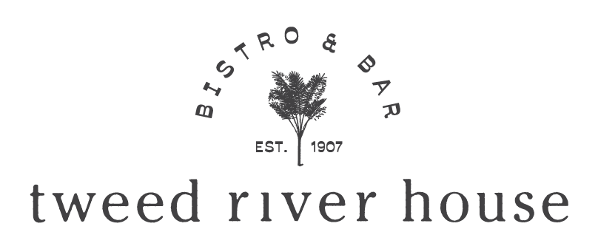

LARGE TABLE DINING EXPERIENCES
FOR 7 – 12 GUESTS

For larger group & event bookings please refer separate fact sheet “large groups” here

DINING AREAS

You can view our dining areas here

Subject to availability you can choose to dine in the Dining Room, the River Verandah, or for the ultimate experience, reserve the exclusive Chandelier Private Dining Room.

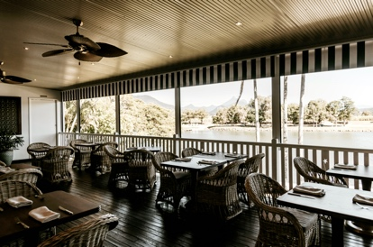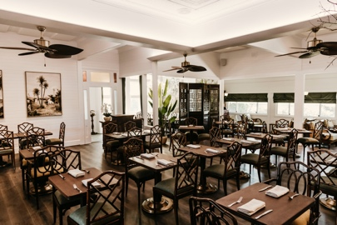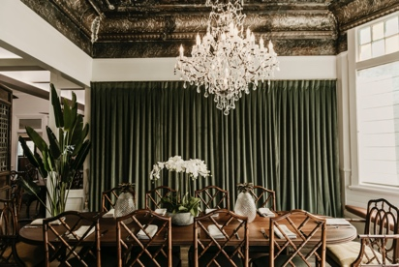
RIVER VERANDAH DINING ROOM CHANDELIER PRIVATE DINING

The Chandelier Private Dining Room seats up to 12 and comes with fine linen and crystal glassware. For exclusive use there is a minimum charge across food and beverages of $1200 for 8 people or $1500 for 10 or $1800 for 12 people. We recommend the set 5 or 7 course Tasting Menu for the ultimate dining experience.

TIME

For large table bookings we allocate 3 hours. If you require longer this must be requested with prior agreement.

MENU We offer a choice of 3 large table menus
(the whole table must choose one of the menus below)

- À la carte 3 course $90 pp

- Set menu 5 course $130 pp or Vegan $115 pp

- Set menu 7 course $165 pp

Children’s Menu For children under 12 we offer a $35
2 course menu (kids main & dessert)

For large tables of 10 and above, we ask guests to preselect their choices. We will send out the large table menu with a selection form to be completed and returned 48hours prior.

LARGE TABLE MENUS

View here refer to LARGE TABLES 7+ MENU tab

Please note our menus are changed regularly in keeping with our seasonal approach
We do not allow BYO drinks, food or cakes.

DIETARY REQUIRMENTS
- Our cuisine contains traces of onion & garlic. We offer gluten free, vegetarian & vegan options. Other dietary needs please request in booking and are subject to confirmation.

BEVERAGES

View here refer DRINKS tab

Drinks are on consumption, or we can create beverage packages for you on request.

SURCHARGES
- 10% applies to bookings on Sundays and 15% on Public Holidays
- 7% gratuity service charge applies only to bookings of 10 + people

BOOKING CONDITIONS
- We require a credit card to secure your reservation. Any bookings that are not secured with a credit card will be released.

We do a pre-authorisation of $45 per person against the credit card. We do not charge this from your card at this time, but it is held should you not cancel your reservation or amend numbers within 24 hours of arrival or no-show on the day. If you turn up on the day with less numbers and we have not been notified in advance, we reserve the right to charge $45 pp for the people not turning up.
CHANDELIER PRIVATE DINING ROOM BOOKINGS

- Requires a $500 deposit at time of booking
- If you cancel within 14 days of arrival your deposit is non-refundable

PAYMENT

- We accept split payments; however, guests must split the bill and advise the payments. We do not calculate split bills for large tables
- Credit card payments incur the applicable merchant fee up to 1.5%

DINING AREA

We reserve the right to change the dining area and table arrangement to suit the size of the group and any weather conditions. Please note there will be other dining guests around and we ask that this is taken into consideration. If you want exclusive use of a dining area, please contact us for a quote.

RESERVATIONS

To secure your large table please email these details to info@tweedriverhouse.com.au
Name
Mobile
Email
Date and time
Which Dining Area
Number of guests including children
Any dietary requests

We will then reserve your booked subject to availability and ask for credit card to secure the reservation per the above booking conditions.

We look forward to welcoming you to the Tweed River House

